Slide 1

# Building Meaningful Relationships with Faculty and Staff

FLORIDA STATE UNIVERSITY

Shannon Bernick, M.Ed., M.S.W.

Accessibility Specialist

Office of Accessibility Services

Slide 2

# Differences in High School and College

* Amount of time spent together
  + Community
  + School
* Number of students
* Job responsibilities
  + Teacher vs. Professor
  + Student



Slide 2

# Importance of Building Meaningful Relationships with Faculty and Staff

* Enhances learning process
  + Provide field expertise /campus resources
  + Act as an advisor or mentor
* Builds professional network
  + Provide reference
  + Nominate for award or scholarship
* Builds campus support system

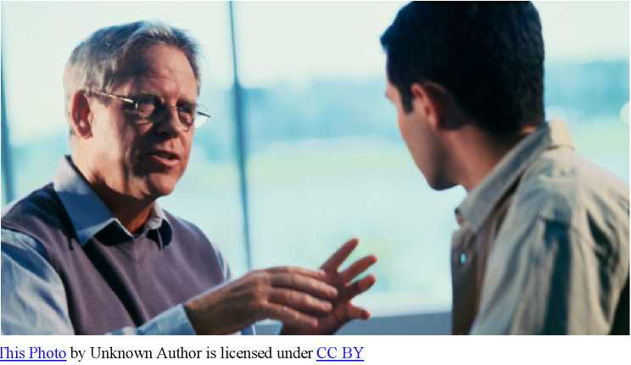

Slide 4

# FSU Faculty Survey

* OAS Survey of 306 FSU faculty members conducted in Spring/Summer 2021
* Asked faculty to rate 15 relationship-building practices as not at all important, slightly important, moderately important, very important and extremely important
* Asked faculty to note any other practices they thought would be helpful

Slide 5

# Results

|  |  |
| --- | --- |
| **Practice** | **Percent Rated as Very Important or Extremely Important** |
| Asking for help when needed | 96 |
| Participating in class | 90 |
| Communicating regularly | 77 |
| Completing assignments on time | 76 |
| Requesting accommodations early | 76 |
| Talking to the professor about your goals | 54 |
| Attending office hours | 54 |
| Asking for advice | 51 |
| Calling the professor by their preferred title | 43 |
| Saying thank you | 42 |
| Introducing yourself at the start of the semester | 41 |
| Earning a good grade | 35 |
| Sitting in the front of the class | 18 |
| Asking for a reference | 11 |
| Researching the professor’s work | 6 |

Slide 5

# Success Tip

“I think most of these things can help build meaningful relationships, but not every student needs to do all of them in order to build a relationship with their professor. If they don't do at least one of them, the professor may not have the opportunity to know them in a large class.”

Slide 7

# Results

|  |  |
| --- | --- |
| **Practice** | **Percent Rated as Very Important or Extremely Important** |
| Asking for help when needed | 96 |
| Participating in class | 90 |
| Communicating regularly | 77 |
| Completing assignments on time | 76 |
| Requesting accommodations early | 76 |
| Talking to the professor about your goals | 54 |
| Attending office hours | 54 |
| Asking for advice | 51 |
| Calling the professor by their preferred title | 43 |
| Saying thank you | 42 |
| Introducing yourself at the start of the semester | 41 |
| Earning a good grade | 35 |
| Sitting in the front of the class | 18 |
| Asking for a reference | 11 |
| Researching the professor’s work | 6 |

Slide 8

# Asking For Help When Needed

* Review the course syllabus for important information.
* Send an email, visit office hours or schedule a meeting as soon as possible when you have a concern.
* Be solution focused.
  + “I’m doing well on the practice problems assigned for homework, but when I took the exam, the problems seemed more difficult, and I didn’t do as well as I wanted to. How can I improve on the next exam?”
* Express gratitude.
  + “Thank you. I think the ideas you shared will be helpful, and I’m going to try them on the next homework assignment.”

Slide 9

# In Their Own Words

“I think teachers like to be useful to their students’ learning process and like to see their growth. So do not be afraid to send a message / go to office hours, just to talk about your academic path, or even something little that you did not understand from class, or something you want to hear more about. You are telling your teacher that they are a meaningful resource for you."



Slide 10

# Participating in Class

* Prepare before class.
  + Take notes including questions you have about the material.
* Answer the professor’s question during class or on a discussion board.
  + Be brief and to the point.
* Ask a question during class or on a discussion board.
  + Clarify class materials or expand upon an idea.
* Respond to a classmate’s comment during class or on a discussion board.
  + Add additional information.
  + Ask a question to clarify or develop what they’ve said.
* Share your thoughts during class or on a discussion board.
  + Refer to your notes or share an experience (e.g. something you saw in a museum or something from a book you read that relates to the class material).
* Share follow-up information after class, in an email, or on a discussion board.

Slide 11

# In Their Own Words

“I think the key to building a meaningful relationship with a professor is to just be an engaged student and reach out to the professor whenever the student is stuck on a problem or concept. Students just need to be engaged and the relationship will usually build organically from there. ”



Slide 12

# What About Online Classes?

“I teach online courses, where it can be more challenging to make personal connections. I appreciate it when students take the time to contact me either via email or phone to discuss their goals and to ask questions. I also think it is good for students interact with me and with other students in synchronous activities (like our Bb Collaborate sessions) and asynchronous activities (including Discussion Board forums). The more information I have about students, the better I can help support their learning goals and needs."

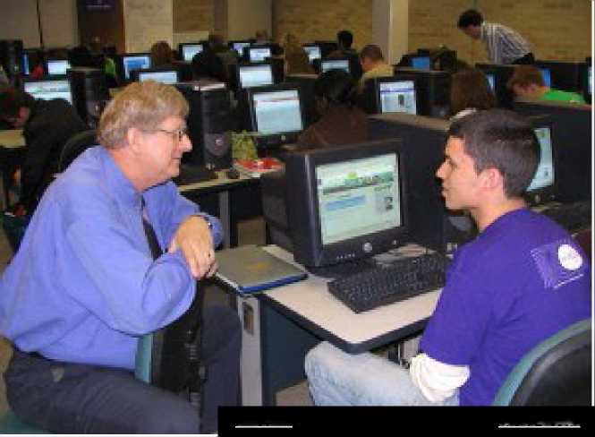

Slide 13

# Requesting Accommodations Early

* Request accommodations in the AIM portal at the start of semester.
* Follow-up your requests with a conversation with each of your professors.
  + Schedule a one-on-one meeting or call.
  + Remember self-disclosure of diagnosis to professors is not required.

Slide 14

# Requesting Accommodations Early

* During your conversations with your professors: • Focus on implementation of accommodations.
  + “I’m a student who is registered with the OAS and has been approved for
* extended time on testing. How do you implement extended time on tests in your course?"
  + Examples: Honor Lock, Zoom Proctoring, testing at the OAS center
    - Negotiate limitations of accommodations.
  + “When my disability-related symptoms flare-up, I might need to use my approved accommodation of taking a break during class. What are some of the limitations of taking breaks in your class?"
    - Examples: safe times, missed material, number of reasonable breaks

Slide 15

# Requesting Accommodations Early

* Reach out to your professor as soon as possible when you have a concern or a flare-up of disability-related symptoms that will impact your work or attendance.
* If you’re unable to contact your professor when you have a flare-up of symptoms or you’re unable to resolve a concern with your professor, contact the OAS.

Slide 16

# FSU Staff Survey

* Survey of 45 FSU Division of Student Affairs staff members conducted in Spring/Summer 2021
* Asked staff to rate 11 relationship-building practices as not at all important, slightly important, moderately important, very important and extremely important
* Asked staff to note any other practices they thought would be helpful

Slide 17

# Results

|  |  |
| --- | --- |
| **Practice** | **Percent Rated as Very Important or Extremely Important** |
| Asking for help when needed | 100 |
| Being polite in your correspondence | 85 |
| Completing required forms in a timely manner | 82 |
| Introducing yourself at the start of the semester | 80 |
| Communicating regularly | 77 |
| Requesting services early | 76 |
| Talking to the staff about your goals | 74 |
| Saying thank you | 62 |
| Attending informational sessions provided by the department | 53 |
| Calling the staff by their preferred title | 47 |
| Reviewing the department's website | 44 |

Slide 18

# Asking For Help When Needed

* Reach out to campus support staff as soon as possible when you have a concern that:
  + Is not resolved after meeting with professor
  + Impacts you across classes (e.g. difficulty managing time, injury or death in the family)
  + Impacts your ability to complete a course or the semester (e.g. medical or mental health)
  + Involves hazing or being the victim of a crime
* If you’re not sure who to reach out to, start with the OAS.

Slide 19

# In Their Own Words

“I think reaching out for help and utilizing our resources is most important. That way we can operate on a level of familiarity with our students when they come back again for help or advice. ”

Slide 20

# Being Polite in Your Correspondence

* Use professional greeting
  + Hello, Good morning/afternoon
* Use person’s preferred title or pronouns
  + Professor, Dr., Ma’am/Sir
  + Only use first name if they have asked you to
* Use professional language
  + Avoid acronyms, slang or curse words
* Introduce yourself
  + Give course title and section for professors
* Be direct and solution-focused
  + State concern and where you need help
* Include an expression of gratitude
* Include your contact information

Slide 21

# Being Polite in Your Correspondence

Hello Ma’am,

My name is FSU Student. I am writing to you today because I experienced a death in my family and will have to miss several of my classes. I would like to meet with you to discuss a letter of support. I am available anytime Thursday and before noon on Friday. Please let me know if either of these times work for you. I can be reached by replying to this email or by phone at 123-555-7890.

Thank you for your help.

Sincerely,

FSU Student

[sampleemail@fsu. edu](mailto:sampleemail@fsu.edu)

123-456-7890

Slide 22

# In Their Own Words

“Being straight forward about what you need or don't understand. I think too often we try to make an excuse for why we need help rather than just owning it. ‘My roommate didn't give me the message, my dog ate my homework, I left you several messages, but you didn't get back to me.' My point is be direct, ask for what you need... We want to help you be successful. ”

Slide 23

# Completing Forms in a Timely Manner

* Complete required forms as soon as possible after you receive them.
  + Note and observe deadlines.
* Follow instructions on form.
  + Answer all questions.
  + Include supporting documentation if necessary.
  + Ask for assistance if you're unsure how to complete them.

Slide 24

# What if I’m Unsure Who Can Help?

If you're unsure who to talk to about your concern, start with the OAS.

- Walk-in hours available.

[oas@fsu.edu](mailto:oas@fsu.edu)

850-644-9566

108 SSB / 874 Traditions Way