Slide 1

How to Prioritize

Nicole Fine

Slide 2

What is prioritizing?

* Allows you to give your attention to tasks that are considered important and urgent while focusing on low priority tasks at a later time
* Creating priorities is necessary to complete everything that needs to be done
* If you create a to-do list and prioritize it, your productivity, sense of accomplishment, and confidence can raise to a whole new level

Slide 3

Why is it difficult?

You feel like you need to do everything at once!

* With ADHD, you may want to complete everything at once because you are either excited to start or because you have a lot to catch up on
* Since you have to focus on one task at a time and leave other tasks unattended, it can create a sense of panic, second guessing, and guilt
* In the beginning, prioritizing may seem overwhelming, leading to unproductivity and lack of motivation

Slide 4

Feel like there is no time to prioritize

* Right now, your life is full of demands
  + School
  + Work
  + Social life
  + You time
* You may be so busy trying to respond to things that come your way, you feel like there is no right time to start
* Taking time to plan and prioritize may feel like a luxury that you will get to some day. But when will that day come?

Slide 5

Decision making is tough!

* When you prioritize, you have to say no to some things and yes to others which can be difficult
* Important to keep in mind the possible outcome of the decision
  + Hanging out with friends vs. starting a paper
  + Binge watching favorite show vs. not attending zoom class
  + Browsing social media vs. doing chores or errands

Slide 6

Being realistic

* Prioritizing involves being realistic
* If you have an accurate estimate of how long tasks take, it will be easier to organize and prioritize tasks
* If you aren’t realistic about time and everything on your agenda, you may think you can get more done in a day than generally possibleSlide 7

Don’t prioritize by default!

Because we can only do one thing at a time, if you don’t actively prioritize the you prioritize by default.

* Littlest first: You do the smallest things on your list first. Even though finishing them feels great, they are often not the most important. And now you may not have time for the bigger task.
* Easy: You pick something because it feels the easiest. This means you may be saving the hardest things for last, which is an avoidance strategy.
* Out of habit: Completing things in order you typically do them, instead order of importance.
* When you feel like it: You might find you wait until you ‘feel’ like doing the task or are ‘in the mood.”

Slide 8

Eisenhower Matrix

When prioritizing, it is important to view what you have planned for the day, and decide what tasks you will complete first

This tool will help you rate tasks based on importance, and time sensitivity

The Eisenhower Matrix

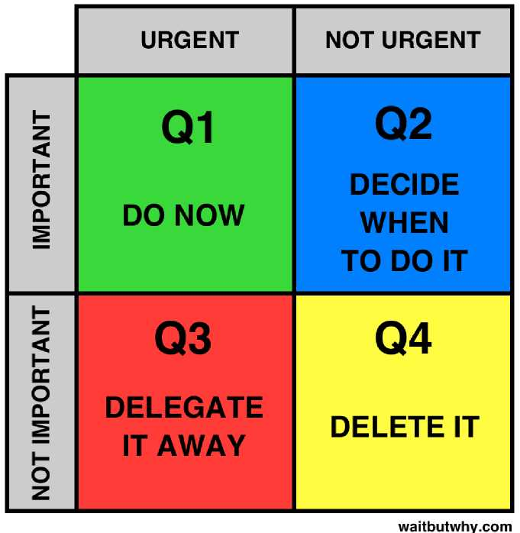

Slide 9

Reward yourself

* It’s important to reward yourself for all of the hard work that you do!
* Life has challenges, and everyone needs a break at some point
* After completing a task, reward yourself with some self care:
  + Video games
  + Yoga
  + Favorite snack
  + Whatever makes you happy : )