Slide 1

Florida State University

Office of Accessibility Services

Department of Student Support and Transitions

Setting Smart Goals

Presented by Shannon Bernick, M.Ed. , M.S.W., Accessibility SpecialistSlide 2

What is goal setting?

A plan for accomplishing an objective.

Can be related to any aspect of your life:

School

Work

Self Care

Social Activities

Relationships

Slide 3

How is goal setting related to students with disabilities?

* In the classroom: Research done by Moeller, Theiler, and Wu (2012) examined the relationship between goal setting and student achievement at the classroom level and found a statistically significant relationship between setting goals and language acquisition
* In treatment: Goal setting has been shown to help improve the outcome in treatment among studies done in adults with depression. (Weinberger, Mateo, & Sirey, 2009)
* In the workplace: Goal-setting theory helps us understand that setting goals is a conscious process and a very effective and efficient means when it comes to increasing productivity and motivation, especially in the workplace.

Slide 4

What are SMART goals?

SMART is a mnemonic acronym used to guide you in setting goals

Specific

Measurable

Attainable

Relevant

Time-bound

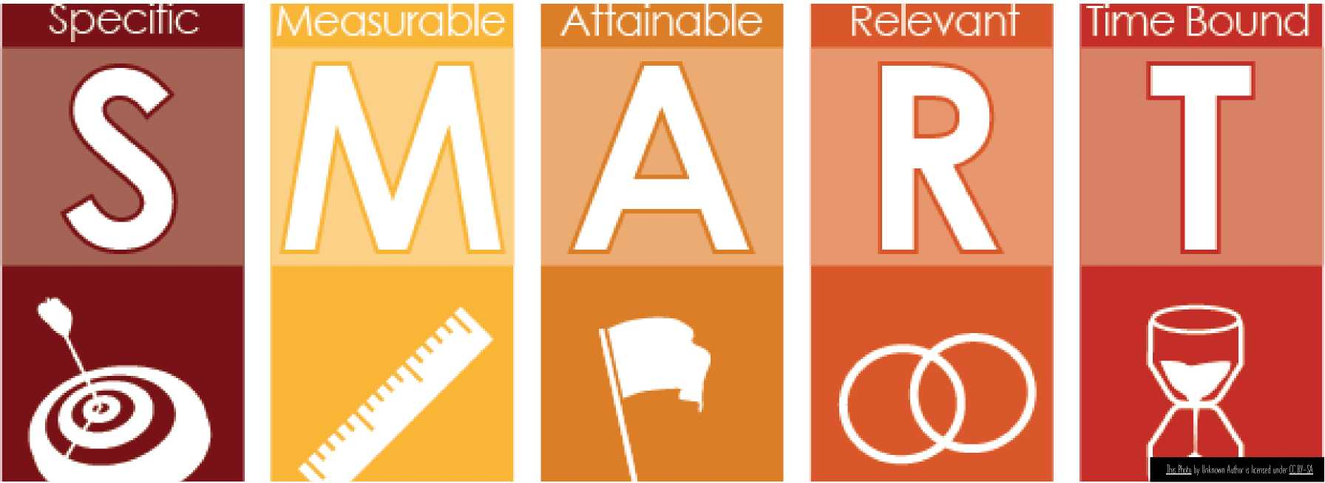

Slide 5

S – Specific

* WHAT objective do you want to achieve?
* Define the goal as clearly as possible.
  + General Example: I want to get better grades.
  + Specific Example: I will make the Dean's list this semester.
  + Specific Example: I will raise my major GPA from 2.9 to 3.1.
  + General Example: I want to be more active.
  + Specific Example: I will go for a walk each day.
  + General Example: I want to meet new people.
  + Specific Example: I will join a student organization.

Slide 6

M - Measurable

How can I measure my progress?

* General Example: Read more for enjoyment.
* Specific Example: I will read my favorite magazine for 20 minutes before bed each night

■Slide 7

Tip for success: track your progress

* Draw a chart and mark each time you complete work towards your goal.
* Keep a photo journal.
* Consider using technology for tracking.
* Try using an [app](https://www.emergingedtech.com/2017/11/best-apps-for-student-goal-setting/).

Slide 8

A – Attainable

* Is my goal achievable?
  + Challenging enough to require effort
  + Reasonable enough to manage
  + Example: I will attend 2 social events each week
    - Consider other obligations
    - Consider personal preferences
* Be sure to consider your current circumstances and resources.
  + Example: I will improve my fitness by working with a personal trainer
    - Consider financial cost
    - Consider personal preferences
    - Consider alternatives
      * Example: Ask a friend or workout with free YouTube videos

Slide 9

R – Relevant

WHY do I want to achieve this goal?

Consider the following:

* Is this goal important to me?
  1. Is it my priority or someone else's?
* Is it aligned with my values?
  1. Do I feel good about working towards this goal?
  2. Is there something else that I'd rather work towards?
* Is my goal consistent with my long-term plans?

Slide 10

T – Timely

* WHEN will I achieve my goal?
* General Given my current circumstances and resources, is it possible for me to achieve my goal in this amount of time?
  + Should I extend my timeline?
    - Example: I had the flu for 7 days
  + Should I shorten my timeline?
    - Example: I really enjoy walking and would like to train for a race.
* Specific: When during the day will I work towards my goal?
  + Example: I will workout at 6:00am
  + Example: I will workout at lunchtime

Slide 11

Taking action

What steps do I need to take to reach my goal?

Example: I will complete my 8-page research paper in 2 weeks.

|  |  |  |
| --- | --- | --- |
| **Action Steps** | **Expected Completion Date** | **Actual Completion Date** |
| I will research my topic and write my three-point thesis statement. | Friday, 02/19/2021 |  |
| I will write the introduction. (1 page) | Saturday, 02/20/2021 |  |
| I will write the first point. (2 pages) | Sunday, 02/21/2021 |  |
| I will write the second point. (2 pages) | Wednesday, 02/24/2021 |  |
| I will write the third point. (2 pages) | Thursday, 02/25/2021 |  |
| I will write the conclusion. (1 page) | Saturday, 02/27/2021 |  |
| I will edit my paper | Sunday, 02/28/2021 |  |
| I will submit my paper | Wednesday, 03/03/2021 |  |

Slide 12

Mental Contrasting

Identifying potential obstacles and possible solutions.

What obstacles might inhibit me from working on or reaching my goal?

What possible solutions are there?

|  |  |  |
| --- | --- | --- |
| **Goal** | **Potential Obstacles** | **Possible Solutions** |
| 1 wilt run three times a week to improve my fitness level. | 1 don't like to get out of bed early. | Workout at lunchtime. |
| 1 wilt make the Dean's list this semester | 1 love to play video games and lose track of time. | Set a timer  Only play video games after schoolwork is done for the day. |
| 1 will participate in a social activity once a week. | 1 get anxious in large crowds. | Plan small events like having a few friends over for dinner |

Slide 13

Tip for success: share your goal with someone

* Dr. Gail Matthews, a clinical psychologist from Dominican University of California conducted a study that shows that "those who write down their goals and share their goals with a friend, as well as send weekly updates, were on average 33% more successful when it comes to accomplishing their stated goals compared to those who merely formulate goals."
* Choose someone who is trustworthy, honest and supportive.
* Be mindful of posting on social media.

Slide 14

Tip for success: create a vision board

Consider using a [vision board](https://www.developgoodhabits.com/vision-board-ideas/)

Steps for Creating Your Own Vision Board:

1. Reflect. Think about what you want in life. Write your thoughts down.

2. Collect. Gather some magazines and cut out images, phrases, and quotes that represent what you want to achieve and that encourage you to work towards your goal.

3. Assemble. On a solid board (e.g., cardboard, cork, or wood), arrange and paste the cutouts in a way that's meaningful for you. If you prefer, you can add some embellishments to your board to make it more personalized.

4. Display. Place the finished vision board in a prominent spot, where you can view it even for just a few seconds every day. Spend a few moments reflecting on your goals each day.

Slide 15

How will i know when I've reached my goal?

* Short Term Goals
  + Example: I will run the 5K Turkey Trot on Thanksgiving Day
* Long Term Goals
  + Am I meeting short term goals related to my longterm goal?
  + Specific Goal: To earn a BS in Nursing
  + Progress: Admitted into Nursing program
  + Are my habits changing?
  + Do I feel differently?

Slide 16

Tip for success: reward yourself for work well done

How can I reward my progress?

* Internal - comes from within
  + Example: I feel more relaxed before bed.
* External - comes from an outside source such as a reward or praise
  + Simple
  + Frequent
  + Free or inexpensive
  + Example: Buy the new copy of my favorite magazine when I finish the current copy

Slide 17

Tip for success: be kind to yourself

When things aren't going as you had hoped:

* Look at your vision board for inspiration and encouragement.
* Look back at all the progress you've made.
* Think about what you would say to a friend who was having trouble reaching their goa.
* Talk to a friend who knows about your goa.
* Consider revising your goal.

Slide 18

Goal setting support @ fsu

[FSU Counseling Center](https://counseling.fsu.edu/)

[Academic Center for Excellence](https://ace.fsu.edu/)

Slide 19

Questions and comments?

Thank you for attending!