# Slide 1

FLORIDA STATE UNIVERSITY

Office of Accessibility Services

Taking AIM: Using the AIM Portal for All Your Accommodation Needs

Shannon Bernick, Accessibility Specialist

KimBoo York, Assistive Technology Coordinator

Ann Clutter, Exam Coordinator

# Slide 2

Topics:

* College Process Overview
* Application Process
* Important Student Links
* Scheduling Tests

# Slide 3

College Process Overview

1. Complete the [online application](https://dsst.fsu.edu/oas)
2. Submit [documentation](https://dsst.fsu.edu/oas/students/applying-for-services/documentation-guidelines)
   1. Dated within five years
   2. Includes diagnosis
   3. [Additional details](https://dsst.fsu.edu/oas/students/applying-for-services/accommodation-process-how-to-request-and-receive-academic-accommodations)
   4. [Support Form](https://dsst.fsu.edu/oas/students/applying-for-services/support-for-accommodation-form)
3. Schedule an intake appointment with Accessibility Specialist
   1. Call 850-644-9566
4. Request accommodations in [AIM portal](https://dsst.fsu.edu/oas)
5. Speak with professors about implementation of accommodations
   1. Disclosure of diagnosis to professors is not required.
6. Use the [AIM portal](https://dsst.fsu.edu/oas) to schedule tests or access class notes
7. Check out assistive technologies
8. Schedule an accommodation review if concern arises or diagnosis changes

# Slide 4

Requesting Accommodations

(the following information is from an OAS handout)

This guide will show you how to request accommodations for your courses using the OAS Portal. Link to OAS portal: <https://whitney.accessiblelearning.com/FSU>

Step 1: Login to fie OAS Portal 24-48 hours after your appointment

* Using the link above, log in to the portal. It takes 24-48 hours for your courses to populate ii the system. If you login and find your courses are not populated, please contact your Accessibility Specialist. Their contact information can be found on the left side of the OAS portal. Your page will look like this:

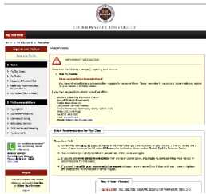

Step 2: On tie Main Page, scroll down and select all the courses you would like to use your accommodations for:

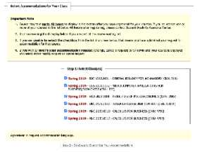

Step 3: Select the button below yow comes that says “Step 2 - Continue to Customize Your Accommodations"

Step 4: For each course, select the accommodations you would like to use and then submit your accommodations request. You are able to select different accommodations for different courses to suit your needs.

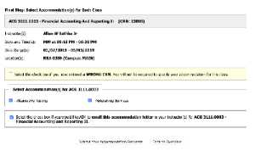

Tip: Select the box underneath your accommodations to have the system automatically email your accommodations letters to your instructors once approved!

Step 5: Your Disability Specialist will review and approve you-accommodations and email the letters to your faculty members.

Step 6: Arrange a meeting with your instructor to discuss your accommodations for the course and how they will be implemented.

Step 7: If applicable to your accommodations, setup note taking services, schedule tests, and arrange transportation using additional instructions given to you from your Accessibility Specialist during your initial appointment.

# Slide 5

AIM Test scheduling Instructions for Students

1. Go to the OAS home page – <https://dsst.fsu.edu/oas>

2. Click on the Student Portal button.

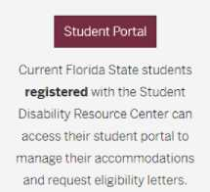

3. Check your Dashboard Overview for upcoming appointments and important messages. Please note that you will not be able to submit a text-scheduling request until you have submitted your accommodations request for that class.

4. On the left side of your Dashboard, you will see Alternative Testing listed. Click on Alternative Testing.

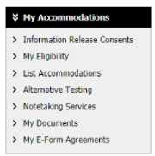

You will now aim it your request by following the prompts and provide our office with the detaiIs of the request. Important to note: requests are subject to approval from both the instructor and the OAS testing center supervisor. You wilI be notified when your exam request is approved.

# Slide 6

Success Tips

* Submit your application and documentation and schedule an intake appointment as soon as possible.
* Make your accommodation requests at the start of each semester.
* Communicate early with your professors about your accommodations.
* Schedule quizzes, tests and exams at the start of the semester or no later than one week prior to the testing date.
* If there is a problem or you have a concern, ask for help as soon as possible.

# Slide 7

OAS Contact Information

Website:<https://dsst.fsu.edu/oas>

Email: [oas@fsu.edu](mailto:oas@fsu.edu)

Phone: 850-644-9566

Shannon Bernick [sbernick@fsu.edu](mailto:sbernick@fsu.edu)