- Underneath the video, select the arrow next to “Details” in blue. Select “Attachments”.
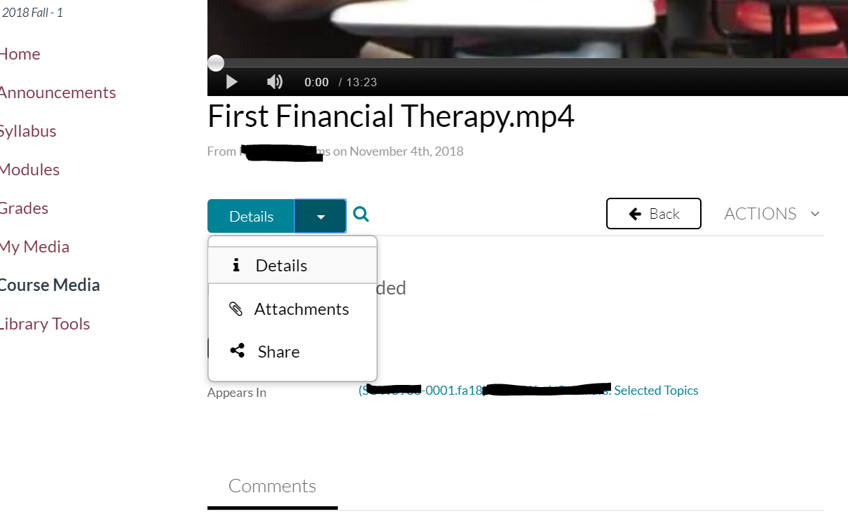
- You will see the first file labeled “transcript.txt”. Scroll right.
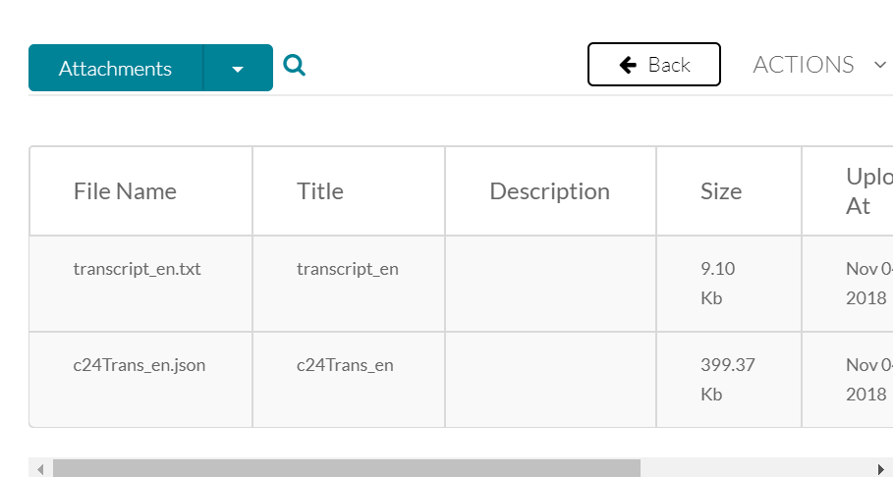
- Select the download icon under actions and the video transcript will download to your computer.
