Slide 1

Time Management

Nicole Fine

Slide 2

Does Any of This Sound Familiar?

I will finish it later

Once I finish this project, I will work on it

I just don't have enough time

It's not that important , it can wait

There is always tomorrow

Slide 3

What Is Time Management

* Planning and controlling the amount of time spent on tasks
* Can help with achieving short and long-term goals
* Help someone assess what needs to be completed within a certain time fram
* Can help someone become more organized
* Can help manage stress (finishing tasks can increase motivation)

Work Smarter Not Harder!

Slide 4

Time Management and ADHD

* A symptom of ADHD is procrastination which can make it difficult to initiate tasks
* Spend so much time managing the symptom, you are not spending time on working on the tasks
* Makes you get further behind on you work, worsening symptoms

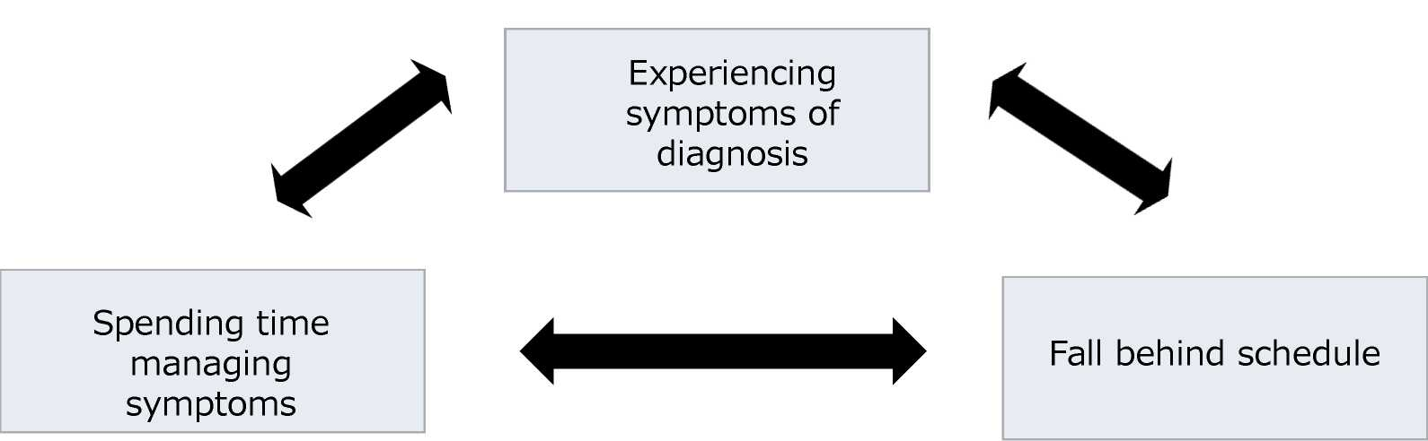

Slide 5

Overestimating Free Time

People tend to believe they have more free time than what they actually do

I typically wake up at 7:00 and have to be at work by 8:30. I have to take into account:

* Showering
* Brushing Teeth
* Hair
* Drying Off
* Makeup
* Lunch
* Getting Dressed
* Breakfast
* Driving

Is There Enough Time?

Slide 6

Time Awareness

* Write down tasks you do throughout the day
* Log how long it takes to do each task from start to finish
* You can keep track with a phone, but a watch is recommended
* Do this for a few days to a week so that you have an accurate estimate of time instead of just simply guessing

Slide 7

Planner

* Gives structure
* If you write out information you tend to remember things better
* I f you don't finish something, you can put it in an open slot on a different day
* Check once in the morning and once at night
* If you see a trend of not being able to finish a specific task, you can break it into sub tasks (don't write a 5-page paper in one day, create a time block on different days to work on it)
* Long-term planning is looking at the whole month, short-term is weekly, and of course look at daily

Slide 8

The Benefits!

Don/t give up I

Work smarter NOT harder

You got this!

Increase motivation and self esteem

More intentional on how to invest your time

You will excel!

Reduces stress

Believe in yourself!

Slide 9

Academic Center for Excellence

One-on-one tutoring

Personal academic consultants

Group tutoring

Civic Literacy

For more information go to [ace.fsu.edu](https://ace.fsu.edu)

For a PAC [tutor@fsu.edu](mailto:tutor@fsu.edu) or call them at 850-645-9151