How to fill out an alternative testing contract
- Go to https://dsst.fsu.edu/oas/faculty
- Click on ‘Instructor Portal Login’
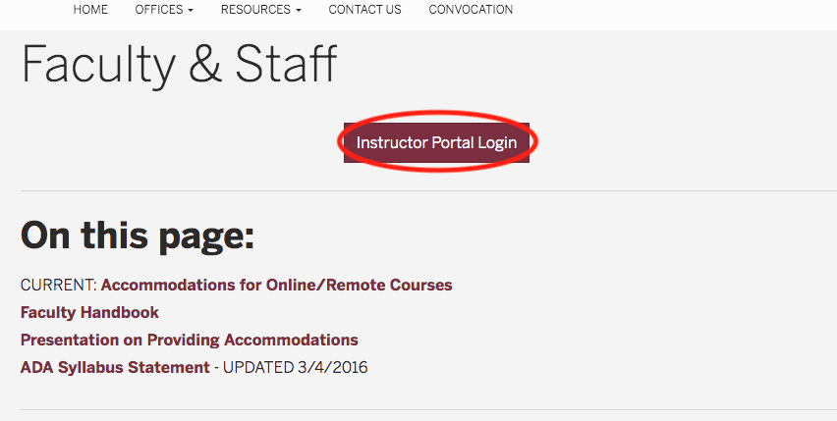
- Log in with your FSU ID and password
- Under the ‘INSTRUCTOR AUTHENTICATION PAGE,’ click on ‘Continue to View Student Accommodations’
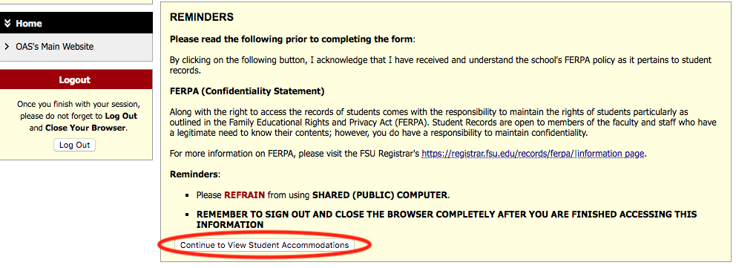
- In the ‘OVERVIEW’ page, click on ‘Alternative Testing’
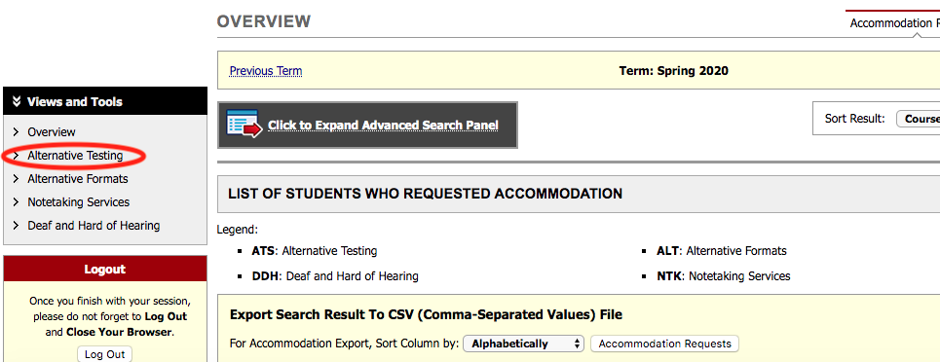
- Select the class you want to fill out an alternative testing contract for and click on ‘Continue to Specify Alternative Testing Contract’
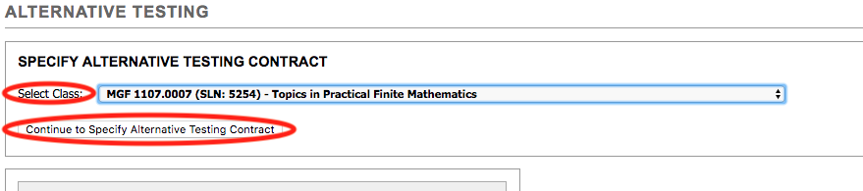
- In the ‘ALTERNATIVE TESTING’ page, fill out the ‘Alternative Testing Contract’
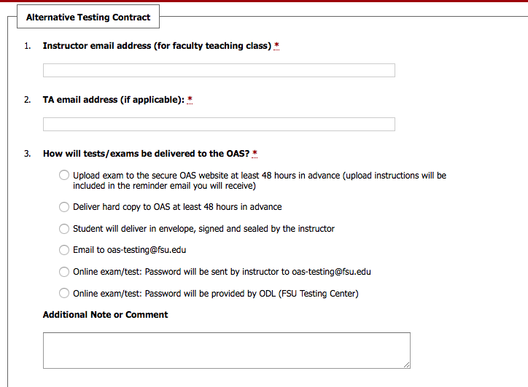
- When you are done filling out the contract, click on ‘Submit Alternative Testing Contract’ to complete the process
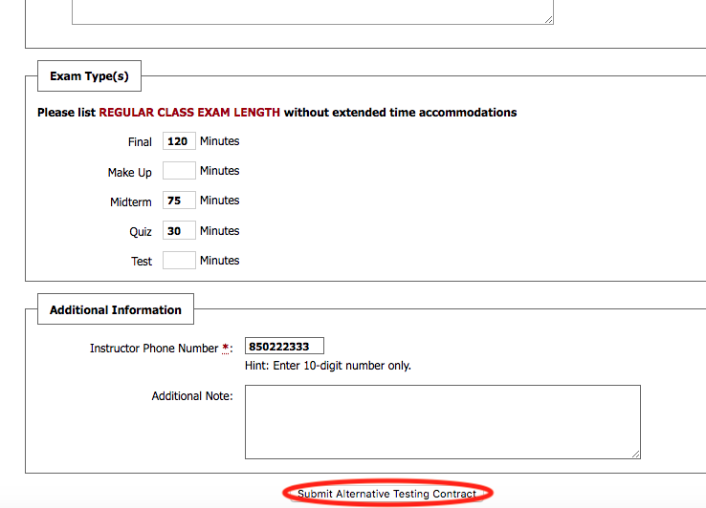

Questions?
Please contact our office if you have any questions or concerns regarding Alternative Testing request by emailing: oas-testing@fsu.edu

