Welcome to the premier issue of the Student Disability Resource Center/SDRC’s monthly online newsletter…
Access-Ability News
We have a ton of valuable information for you! Don’t worry - take your time, take small bites, chew slowly and remember – we’re not going anywhere, so you can always find us right here.

Asst. Dean Jennifer’s Corner
Do you have a pressing issue or concern that needs immediate attention from a Disability Specialist?
You are welcomed to stop by the Front Desk for a “walk-in” from 9AM-4:30PM, Monday - Friday.

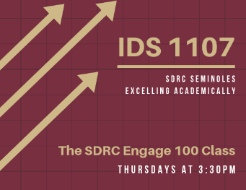
Did You Know?
IDS1107 is a 16 week, zero-credit hour course to offer extra academic support specifically for first year SDRC students.
So if you prefer a smaller class setting, frequent check-ups & assistance – this is the course for you! We meet Thursday afternoons from 3:30 – 4:30 pm. Fill out the registration form at this hyperlinked Qualtrics link. For more information, email Spencer Scruggs at sscruggs@fsu.edu.

Tic… …Toc
Ready for the Fall semester to begin? Make sure you:
- Prepare your Fall agenda,
- Check out where all your classes are,
- Attend the Involvement Fair on Tues, 8/27

Mark Your Calendars

Fall Semester Kickoff
Attention SDRC students who want:
- more individualized access to info about & networking with FSU resources,
- training on college success skills, and
- opportunities to connect with peers having similar needs…
Sign up for our all-day Fall Semester Kick Off on August 23rd.
Tell your folks that we have also included a special track for interested family members wanting to learn how to best support your journey with FSU. For more information, email Ashley Archer-Doehling at anarcher@fsu.edu. To reserve a limited spot/RSVP, please fill out this form.

Workforce Recruitment Program
The Workforce Recruitment Program is a great fit for post-secondary students with a disability who are:
- highly motivated,
- recently graduated, and
- eager to prove their abilities in the workplace with a paid summer internship or permanent job.
This is a comprehensive recruitment and referral program that connects qualified students with public and private sector employers nationwide. Don’t miss the chance to jumpstart an internship or career opportunity! The Career Center has announced Aug. 26th for the 2019-2020 application opening. For more information, contact Emily Kennelly at ekennelly@fsu.edu.

Remember to…
Email your Instructor Letter for accommodations during the first week of class at the SDRC Student Portal.

